**Workstreams**

**Smart Places & Infrastructure**

Catalyses Australian IoT competitive advantage for Smart Cities in collaboration with urban infra related Workstreams.

Co-Chair: Sophia Chrysanthos, City of Parramatta

Co-Chair: Adam Beck, Urbanism

**Food and Agribusiness**

Increases the potential of the Australian agricultural sector through key digital productivity drivers underpinned by IoT.

Co-Chair: Jonathon Quigley, Sparklabscultiv8

**Water**

Accelerates the adoption of IoT and related technologies in the Australian water sector to deliver value.

Chair: Paul Siemers, Melbourne Water

Vice-Chair: Sean Cohen, Suez

**Energy**

Connects the energy sector, enables knowledge sharing and develops IoT capability that enhances the energy value chain.

Co-Chair: Mark Atkinson, Telstra

Co-Chair: Ken Holder, KPMG

**Manufacturing**

Helps the Australian manufacturing sector leverage step change business value from IoT and related technologies.

Co-Chair: Darren Hungerford, Downer Group

Co-Chair: Anthony Wong, Rockwell Automation

**Health**

Promotes greater awareness of the IoT value proposition for healthcare in Australia and accelerates adoption.

Chair: Vlad Tohadze, TPG Telecom

**Construction**

Enable the Construction industry to embrace IoT technology to support better safety, compliance and productivity outcomes.

Co-Chair: Angus Kennard, Inauro

Co-Chair: Steve Lennon, GHD

**Transport Services**

Raises awareness of IoT capability in the Australian transport sector and promotes IoT enablement of major transport infrastructure.

Chair: Richard Duggan, NEC

**Start-Ups**

Builds the Australian IoT start-up ecosystem through sustained community development to help Australian IoT start-ups succeed.

Co-Chair: Matt Tati, Milcane

Co-Chair: Eike Zeller, Stone & Chalk

**Workforce, Skills, and Education**

Chair Dominic Schipano

Sean Cohen

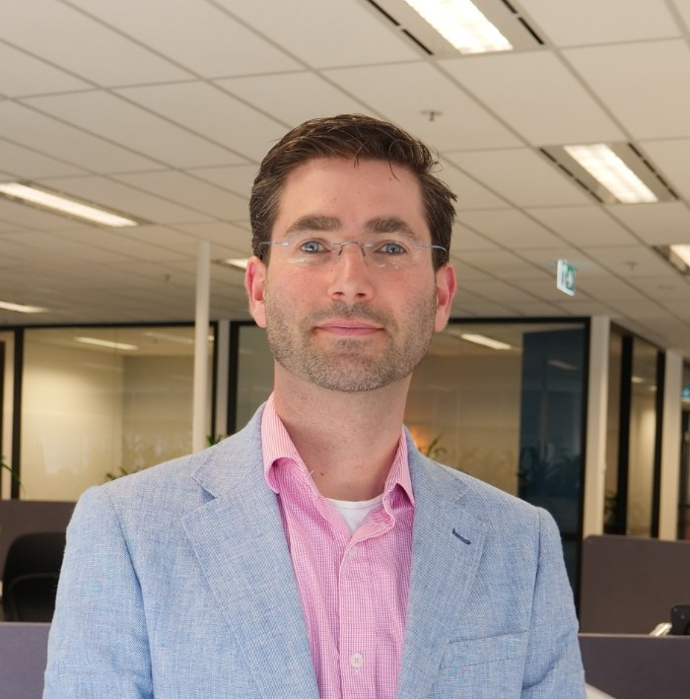

Sean is the Head of Smart Metering for Suez Water Australia, working to add intelligence to the infrastructure that supports our communities.

As an engineer, he strongly believes that IoT should meet the levels of performance and reliability that we’ve come to expect from \***all**\* our infrastructure. Whether it’s a bridge or a battery, it should be built to last.

Sean has built a career on technology development and deployment, across electricity, water & wastewater treatment, communications systems, and medical devices.

Sean has also been instrumental in working with the WIZE Alliance to make the WIZE open standard available for digital metering and utility IoT applications in Australia.

Sean is also a massive nerd (his daughter had a soldering party for her birthday).

Steve Lennon

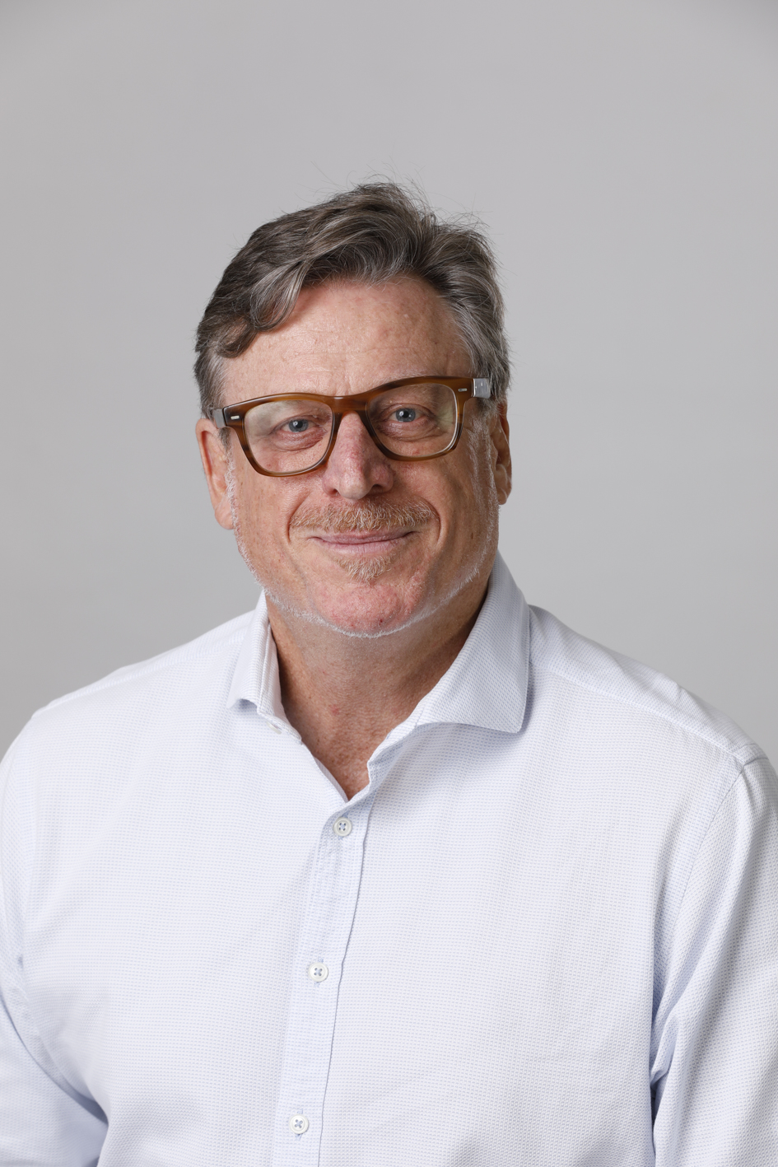

**Steve Lennon, Practice Director Australia, GHD Digital**

Steve Lennon leads the GHD Digital business in Australia and is a member of GHD’s global Digital leadership team. He advises private and public sector clients in the energy, water, built environment and infrastructure sectors on the digital transformation of their assets, operations and business models so they can rapidly adapt to change and remain competitive.

Steve originally qualified as a Chartered Accountant and has served as managing director, Australia of the global creative agency Imagination; principal, management consulting with Arup, the design and engineering firm and in consulting leadership roles at several global IT services firms including DXC, SMS Management & Technology, Fujitsu, CGI and Cognizant.

Steve is a Graduate Member of the Australian Institute of Directors, a Board Member of Regional Development Australia, Sydney, a CEDA Trustee and a Non-Executive Board Member for Basketball NSW. He is listed on the NSW Government prequalification scheme for Audit & Risk Committee members and has served in this capacity for the WestConnex Delivery Authority.

Angus Kennard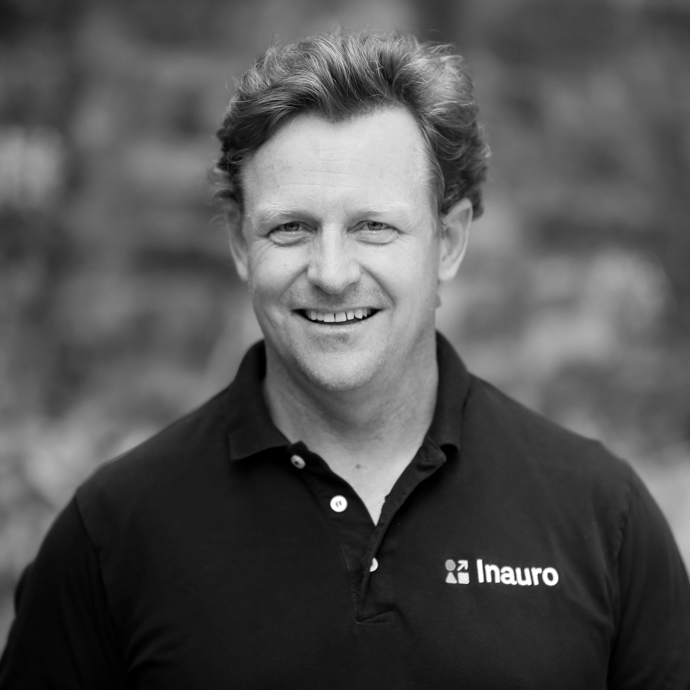

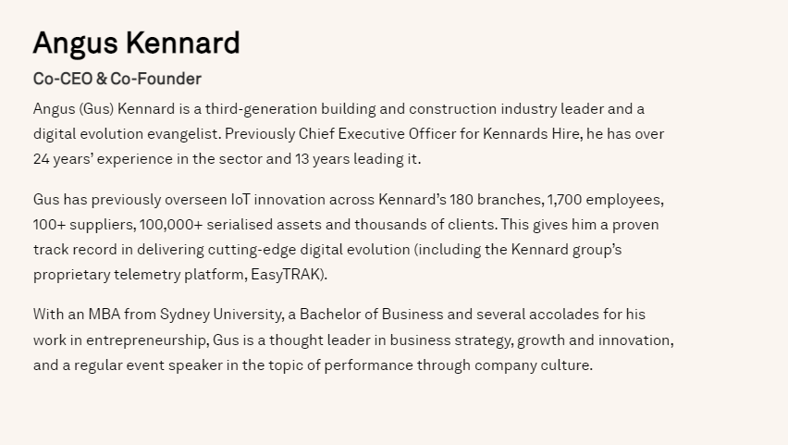

Angus (Gus) Kennard is a third-generation building and construction industry leader and a digital evolution evangelist. Previously Chief Executive Officer for Kennards Hire, he has over 24 years' experience in the sector and 13 years leading it.

Gus has previously overseen IoT innovation across Kennard's 180 branches, 1,700 employees, 100+ suppliers, 100,000+ serialised assets and thousands of clients. This gives him a proven track record in delivering cutting-edge digital evolution (including the Kennard group's proprietary telemetry platform, EasyTRAK).

With an MBA from Sydney University, a Bachelor of Business and several accolades for his work in entrepreneurship, Gus is a thought leader in business strategy, growth and innovation, and a regular event speaker in the topic of performance through company culture.

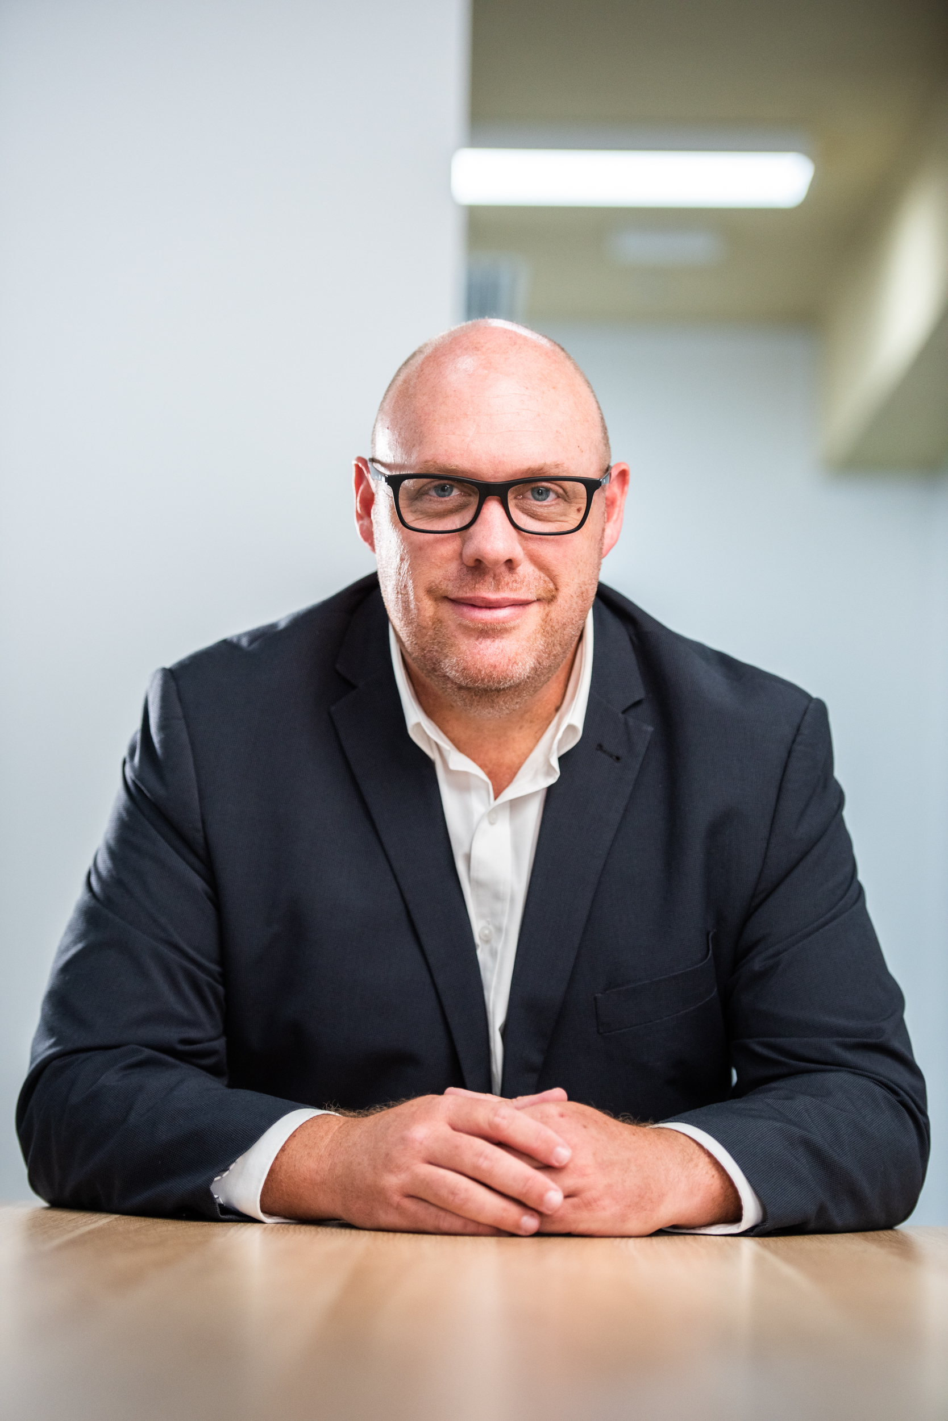

**Adam Beck**

Head of Digital Urbanism, ENE.HUB

Adam is an urbanist who has worked for private sector consultancies and leading global non-government organisations to advance sustainable community outcomes in cities around the world for almost 30 years.

He is Head of Digital Urbanism at ENE.HUB, a role that has him working collaboratively with Council’s and land authorities to realise the benefits of shared urban infrastructure in connecting, activating and measuring urban life.

Adam is Chair of the Standards Australia Digital Twin Working Group, Co-Chair of the Smart Places and Infrastructure Workstream at the Internet of Things Alliance Australia and is Co-host of the podcast ‘Digital Built Australia’.

Adam is also Co-founder and Director of TEMPO Institute, a digital built environment education provider.

He was also the Founding Executive Director of the Smart Cities Council Australia New Zealand, a role he had for 6 years.

Adam previously had roles as Director of Innovation at EcoDistricts in Portland Oregon in the United States, Executive Director at the Green Building Council of Australia and various consulting roles with global consulting firms Arup and GHD for 15 years.

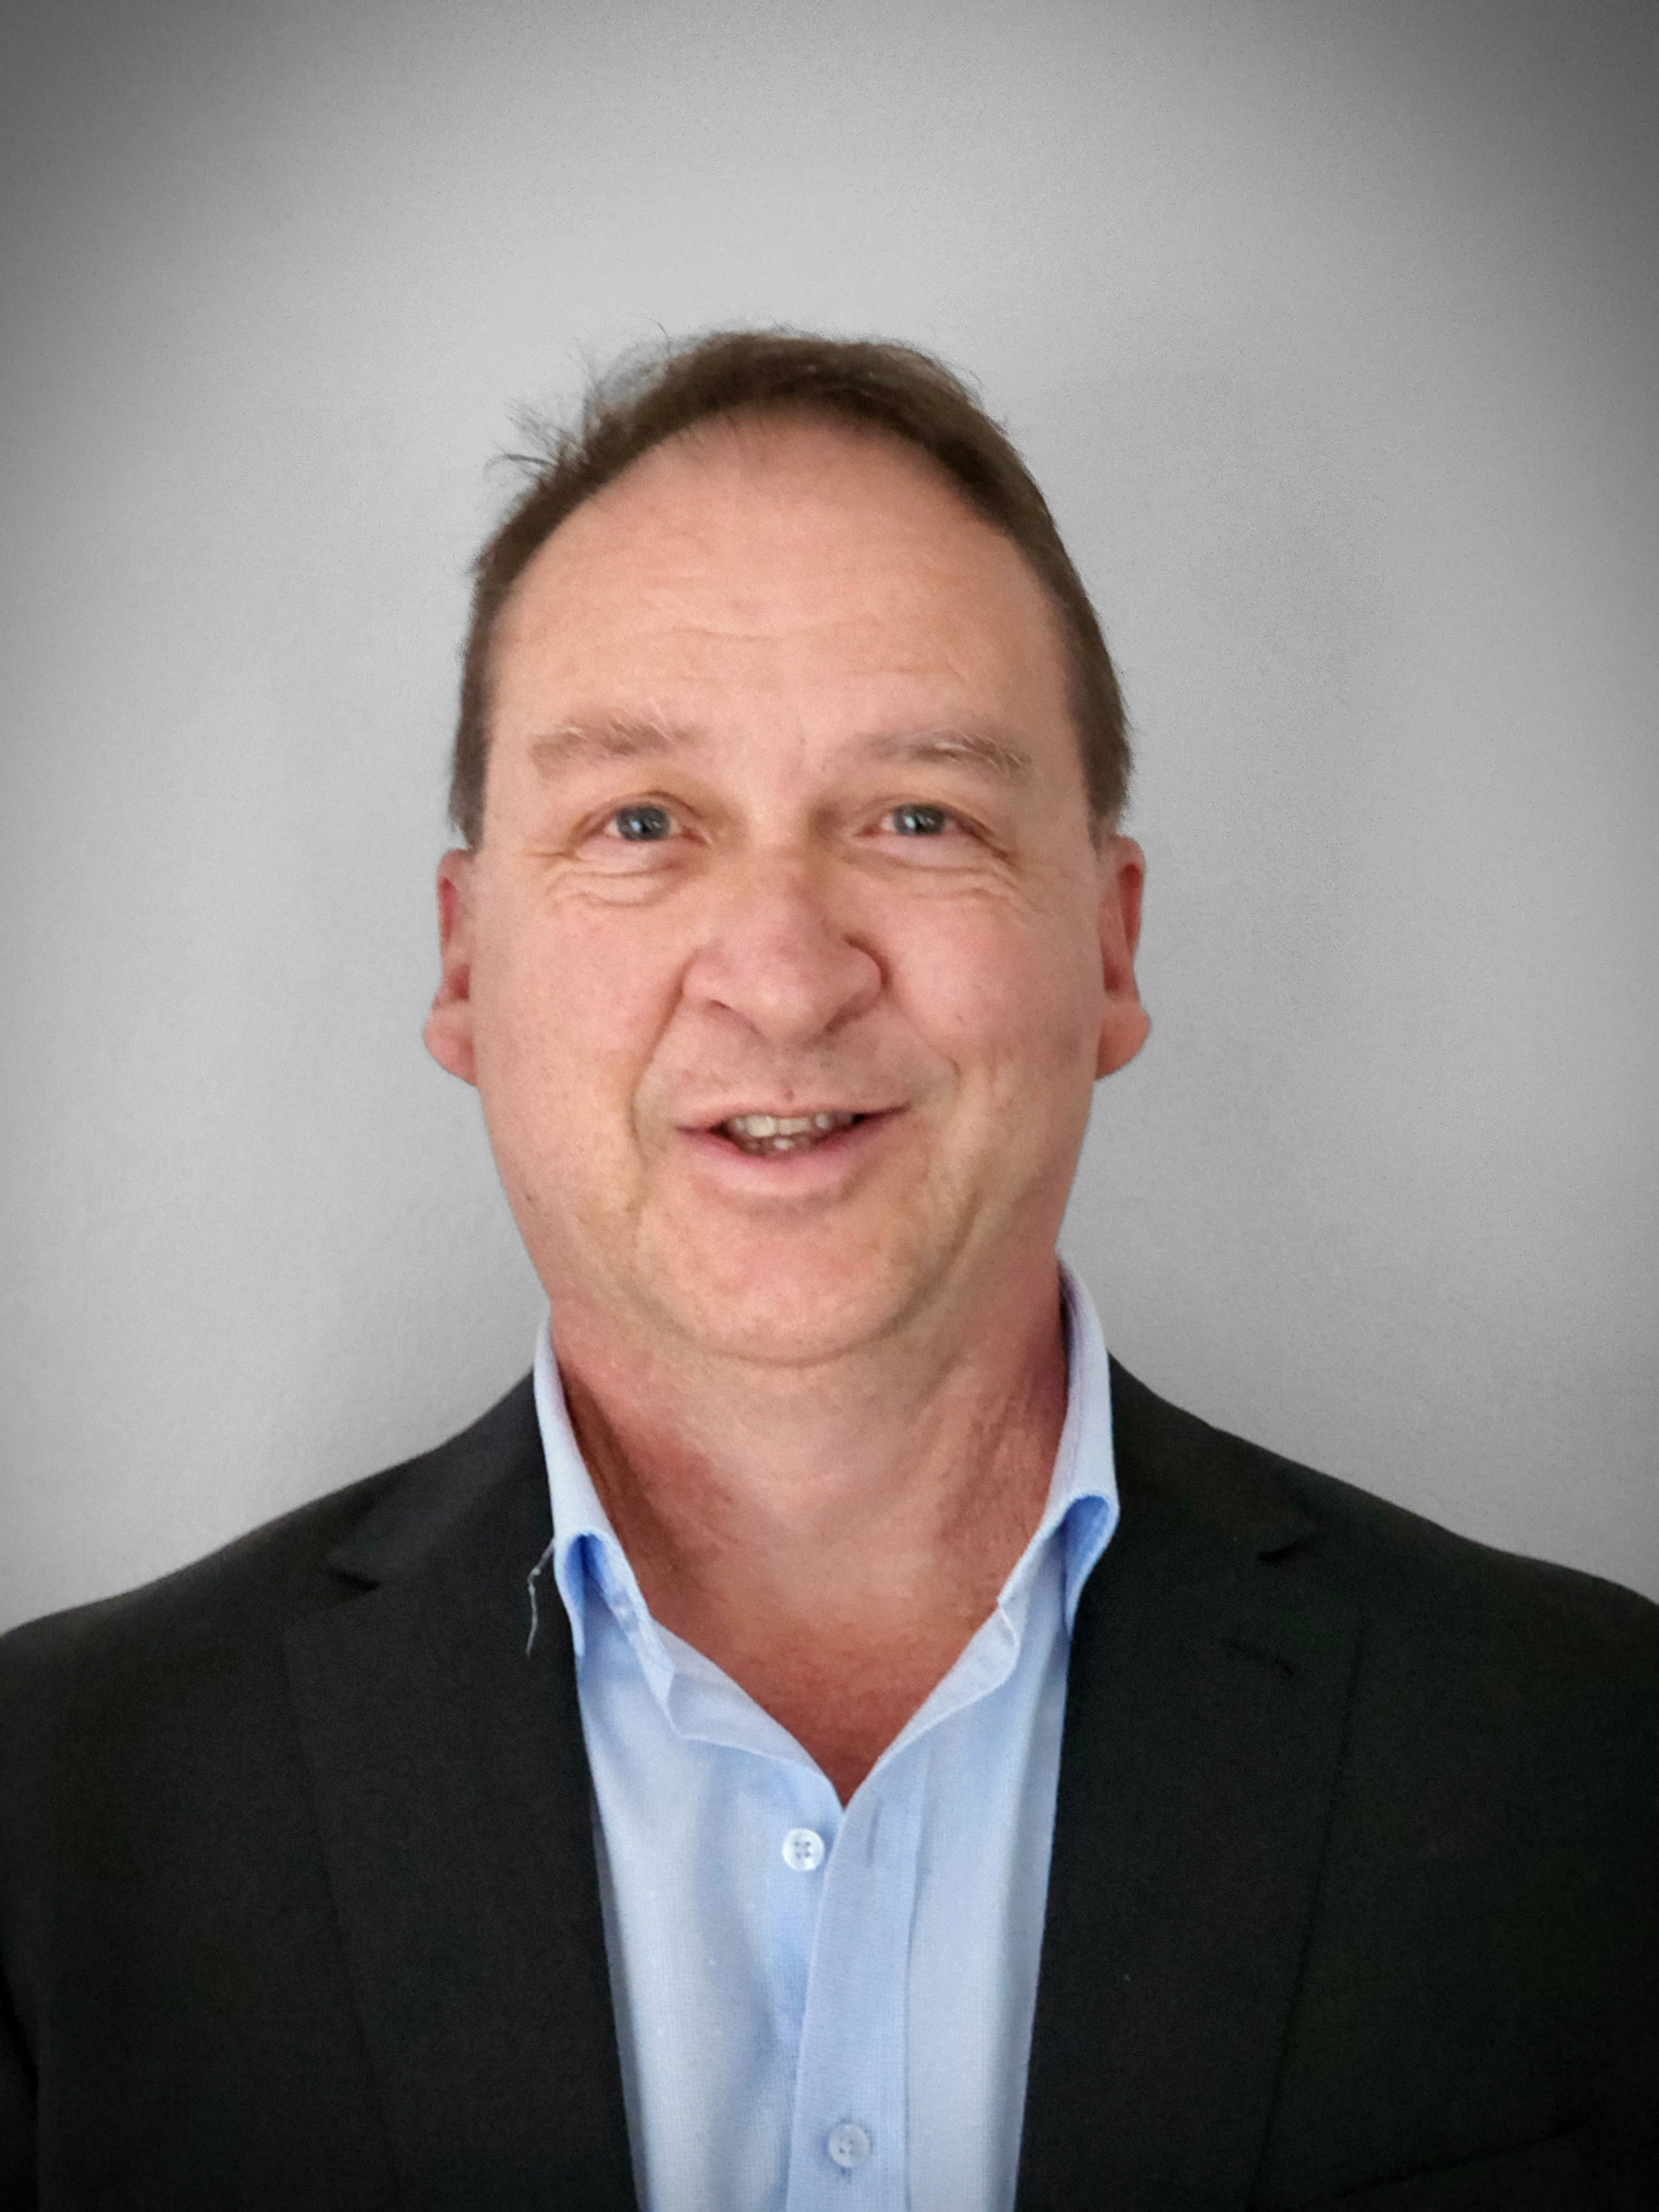

Here is the short write up:

Vlad Tohadze graduated as an Electrical Engineer from the University of Technology Sydney. Vlad spent his early years involved in telecommunications overseeing the first fibre optic installations in the country and the initial release of the cellular and paging networks.

Broadening his knowledge as an R&D hardware designer of electronic solutions within the instrumentation, control and medical industry sectors, he was known as the Engineers engineer and held senior roles in Engineering, Marketing and Business Development within the Australian and New Zealand electronics marketplaces.

Over the last 10 years Vlad has embraced the Internet of Things helping businesses to innovate, disrupt and lead in their respective markets using the power of the Internet of Things. Industries including healthcare, energy, security, government, transportation, finance, consumer, industrial and instrumentation have all benefited using his insights for connecting remote assets into making meaningful decisions to improve business expansion and operations locally and globally.  
Having worked in the technology sector for over 3 decades, the advent of Internet of Things has allowed Vlad to specialise in helping C-level executives to understand the vision into what is happening with their products in the field in order to improve the bottom line. With his engineering background, he removes the technical complexities of an IoT solution and presents this in a simple to understand language. He has the global experience to take customers solutions beyond the boundaries of a country and able to market to every corner of the world.  
Vlad has seen a significant acceleration towards the adoption of Internet of Things with businesses starting to venture into this area without the appropriate know how. He has helped the transformation easier and enabled businesses to deliver better bottom line results using the efficiencies of the Internet of Things.

Currently Vlad holds the role of IoT Specialist at Vodafone/TPG Telecom and believes in connecting every end asset to help transform lives and businesses especially in the medical technology sector where he has overseen some world leading IoT designs developed in Australia and marketed throughout the world. He believes that Australia continues to produce world class medical device companies exporting Australian innovation to the world and is looking forward to the IoTAA Healthcare Workstream providing thought leadership to new models of care through innovative IoT technology. 

Ken Holder

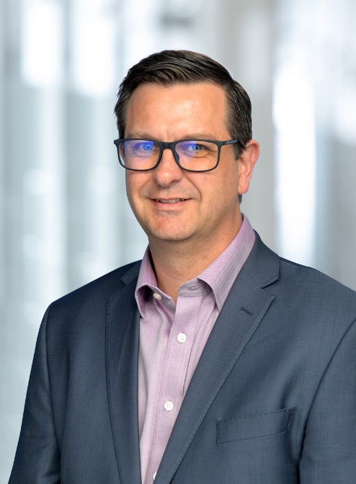

Co-Chair, Energy Workstream

Ken is a director in the Engineering, Assets & Project Delivery team within KPMG’s Infrastructure, Assets & Places division.  He specialises in electricity networks and operational technology (OT) and works with energy and water clients where he assists them to:

* tap into the transformative and economic opportunity presented by connecting the digital world with the physical world, including aligning asset management and investment programs with energy transition drivers of decarbonisation, decentralisation, and digitisation;
* uplift their asset management systems, strategies and internal capabilities; and
* develop asset investment programs and associated business cases that are underpinned by sound asset management and data-driven decisions.

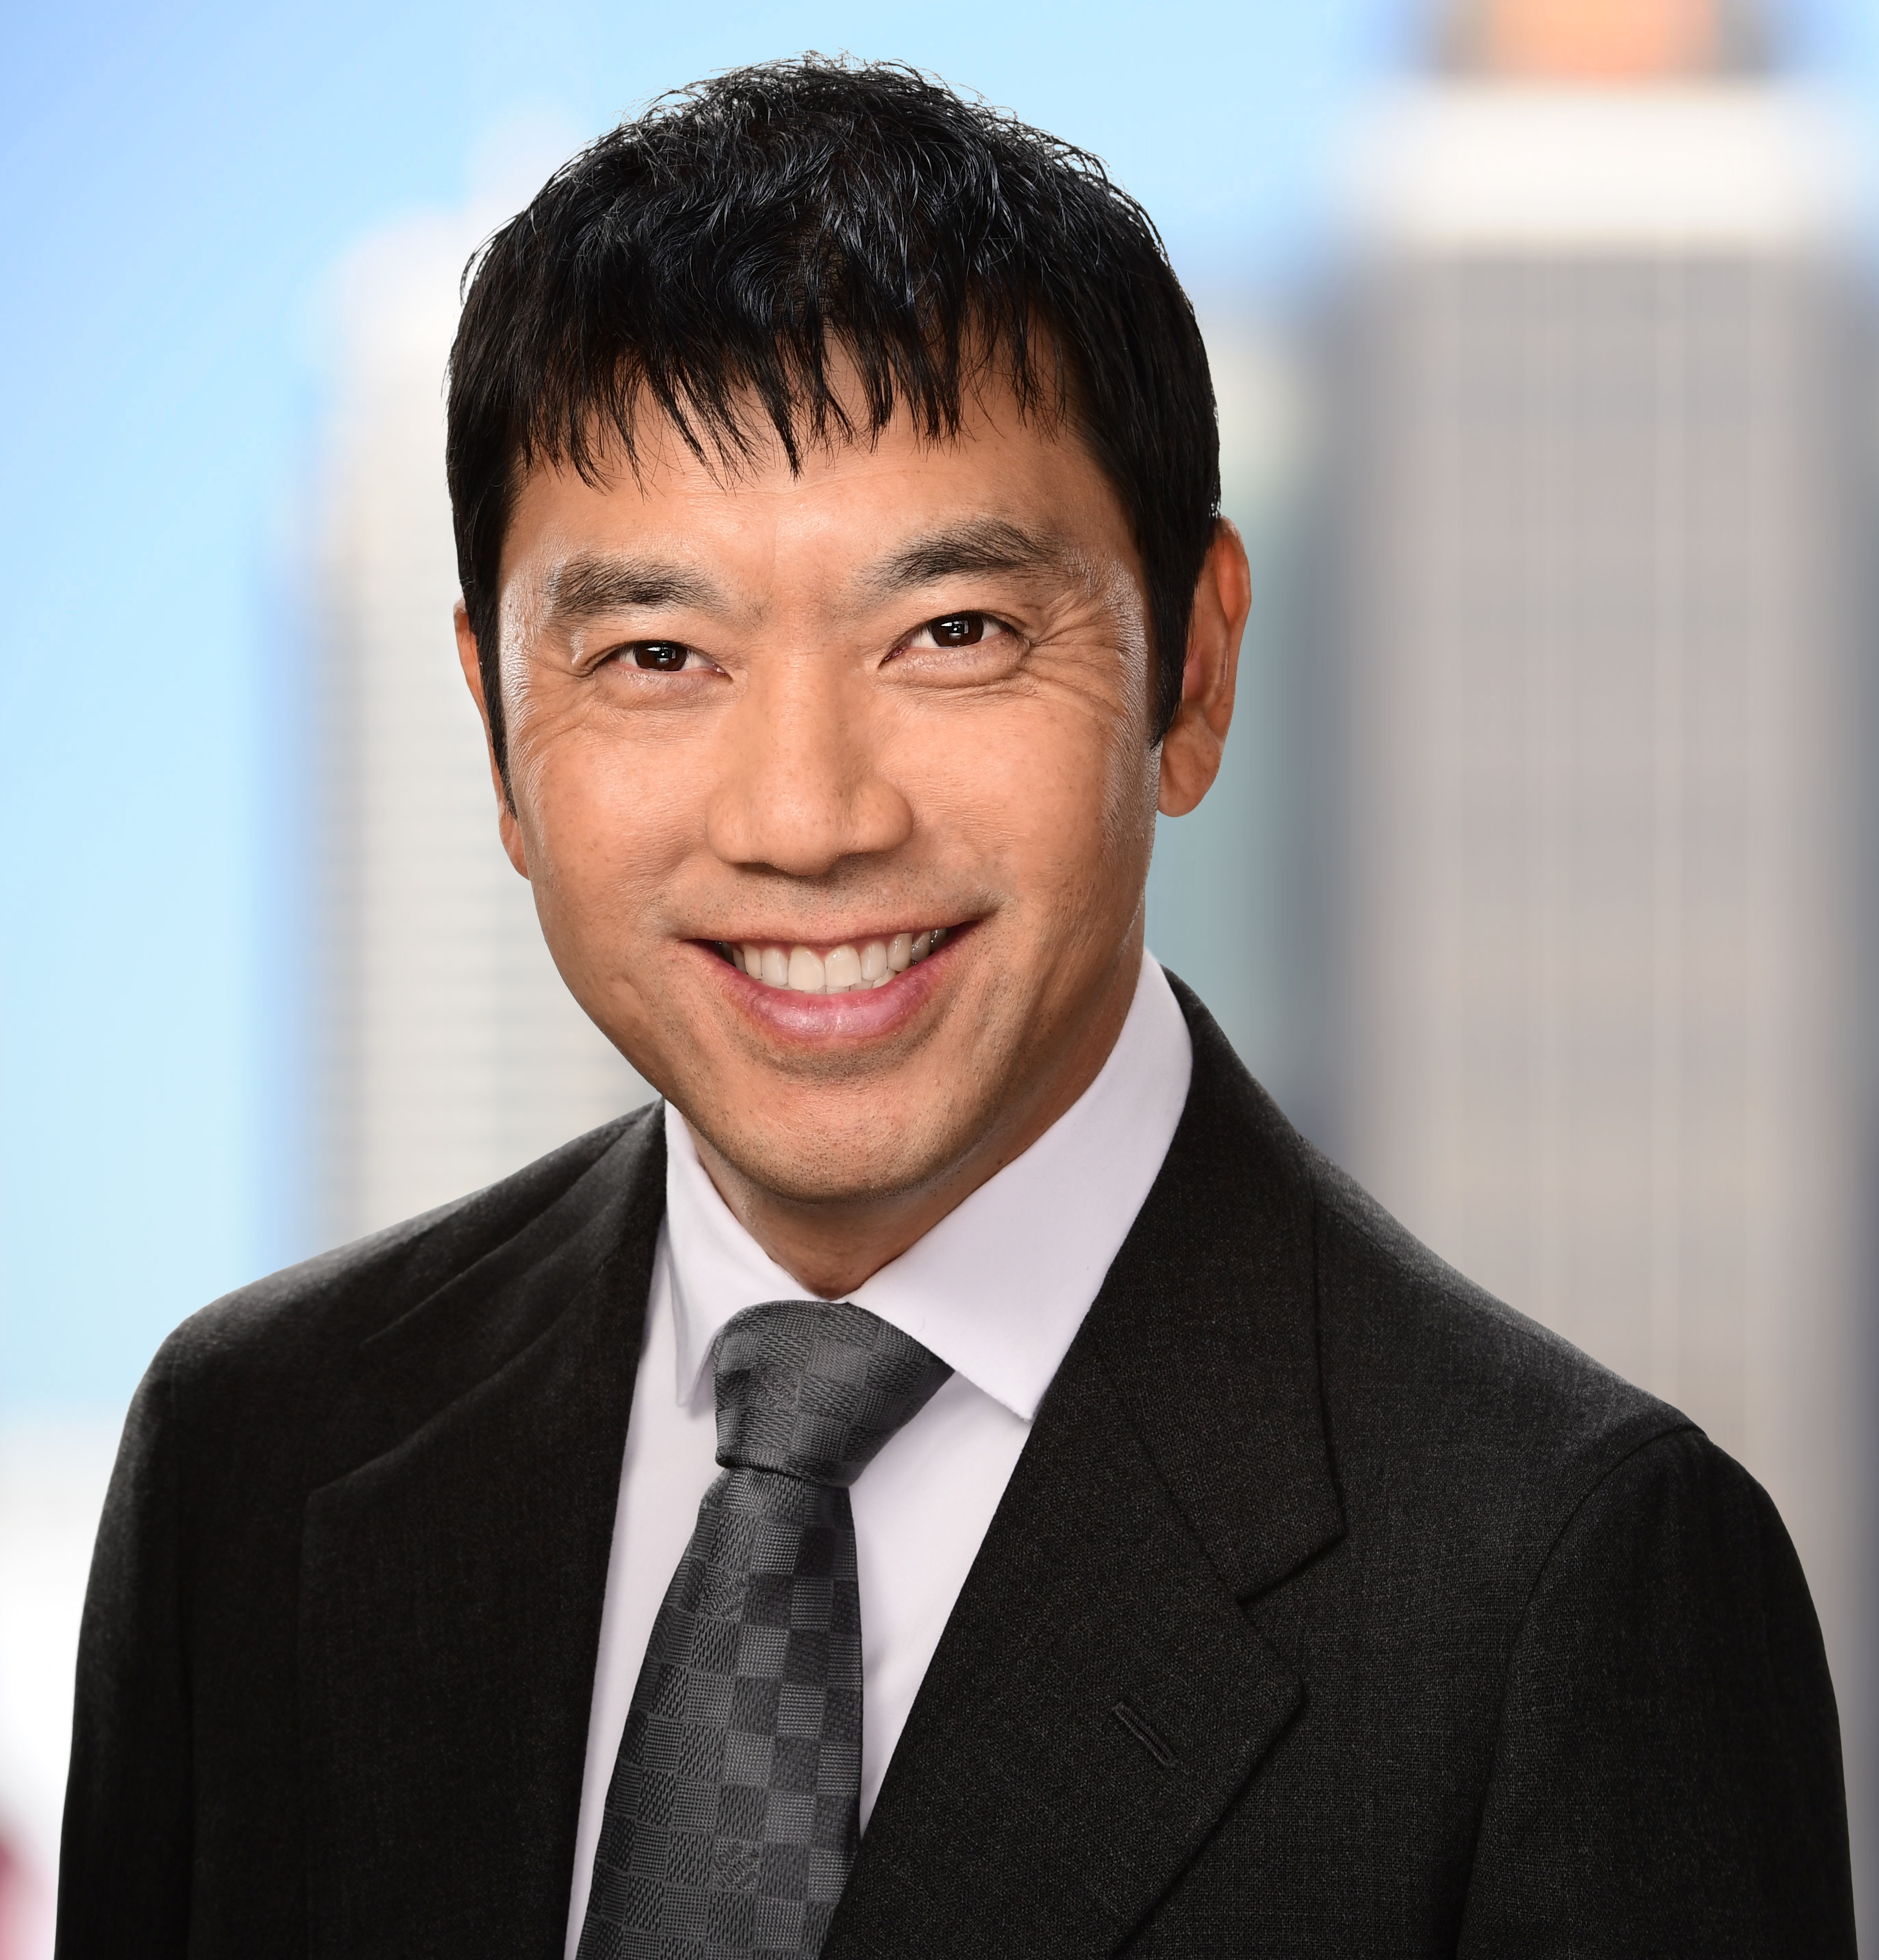

*“Anthony Wong has over 20 years’ experience in sales and strategy roles in Australia, France, and the USA specializing in Smart Manufacturing and Digital transformation to transform the industry from being automated to autonomous.  He is currently the Regional Director for the South Pacific Region for Rockwell Automation based in Sydney.”*